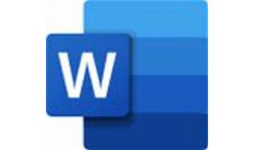

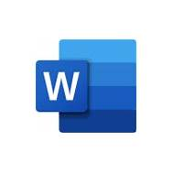

Explore

**Microsoft Word** is a **word processor** developed by Microsoft that allows you to create professional-quality documents, reports, letters, and résumés. [It offers features such as spell check, grammar check, text and font formatting, HTML support, image handling, advanced page layout, and more](https://www.computerhope.com/jargon/m/microsoft-word.htm) [1](https://www.computerhope.com/jargon/m/microsoft-word.htm)[2](https://en.wikipedia.org/wiki/Microsoft_Word).

Here are **five free resources** where you can learn more about Microsoft Word:

1. [**Microsoft Support: What is Word?**](https://support.microsoft.com/en-us/office/what-is-word-aee9c7ff-f9c5-415f-80dc-103ad5e344d7): This official Microsoft article provides an overview of Word’s capabilities and features [3](https://support.microsoft.com/en-us/office/what-is-word-aee9c7ff-f9c5-415f-80dc-103ad5e344d7).
2. [**Computer Hope: What is Microsoft Word?**](https://www.computerhope.com/jargon/m/microsoft-word.htm): Learn about Word’s functionalities, including formatting, spell checking, and more.
3. [**GCFGlobal: Free Word Tutorial**](https://edu.gcfglobal.org/en/word/): Explore tutorials on formatting text, saving and sharing documents, modifying spacing, using tables, and other Word-related tasks.
4. [**Coursera: Getting Started with Microsoft Word**](https://www.coursera.org/projects/getting-started-microsoft-word): A video tutorial that guides you through creating and saving a Word document using the free version of Microsoft Office 365.
5. [**Microsoft Support: Word for Windows Training**](https://support.microsoft.com/en-us/office/word-for-windows-training-7bcd85e6-2c3d-4c3c-a2a5-5ed8847eae73): Access training guides, articles, and how-to videos specifically for Word on Windows [4](https://support.microsoft.com/en-us/office/word-for-windows-training-7bcd85e6-2c3d-4c3c-a2a5-5ed8847eae73).

Happy learning! 📝👩‍💻